**Project Design Phase-II**

**Data Flow Diagram & User Stories**

|  |  |
| --- | --- |
| Date | 12 May 2023 |
| Team ID | PNT2022TMID13788 |
| Project Name | Covid vision : Advanced covid 19 detection from lung x-ray with machine learning or deep learning. |

**Data Flow Diagrams:**

A Data Flow Diagram (DFD) is a traditional visual representation of the information flows within a system. A neat and clear DFD can depict the right amount of the system requirement graphically. It shows how data enters and leaves the system, what changes the information, and where data is stored.



Example: DFD Level 0 (Industry Standard)

**Example:** [**(Simplified)**](https://developer.ibm.com/patterns/visualize-unstructured-text/)

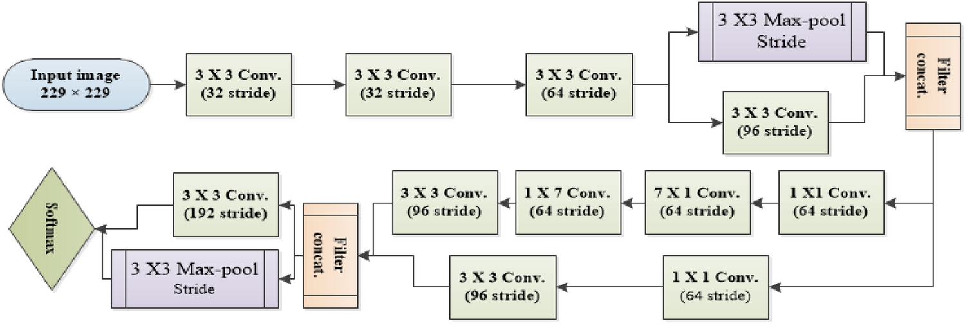

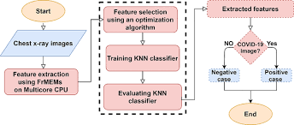

**User Stories**

COVID-19, caused by SARS-CoV-2, has resulted in a global pandemic recently.

With no approved vaccination or treatment, governments around the world have issued guidance to their citizens to remain at home in efforts to control the spread of the disease.

* The goal of controlling the spread of the virus is to prevent strain on hospitals.

| **User Type** | **Functional Requirement (Epic)** | **User Story Number** | **User Story / Task** | **Acceptance criteria** | **Priority** | **Team Member** |
| --- | --- | --- | --- | --- | --- | --- |
| Customer (Mobile user) | Registration | USN-1 | As a user, I can register for the application by entering my email, password, and confirming my password. | I can access my account / dashboard | High | Jeevitha.p |
|  |  | USN-2 | As a user, I will receive confirmation email once I have registered for the application | I can receive confirmation email & click confirm | High | Savithri.v |
|  |  | USN-3 | As a user, I can register for the application through Facebook | I can register & access the dashboard with Facebook Login | Low | asha |
|  |  | USN-4 | As a user, I can register for the application through Gmail |  | Medium | savithri |
|  | Login | USN-5 | As a user, I can log into the application by entering email & password |  | High | jeevitha |
|  | Dashboard |  |  |  |  |  |
| Customer (Web user) |  |  |  |  |  |  |
| Customer Care Executive |  |  |  |  |  |  |
| Administrator |  |  |  |  |  |  |
|  |  |  |  |  |  |  |
|  |  |  |  |  |  |  |
|  |  |  |  |  |  |  |